CENWP-OD-B 21 September 2022

MEMORANDUM FOR THE RECORD

SUBJECT: 22BON090 MFR AFF Salmonid Mortality

On 21 September, Columbia River Inter-Tribal Fish Commission (CRITFC) Biologists notified Bonneville Project Biologists of a Salmonid mortality found on the valve 15 trash rack in the Adult Fish Facility (AFF). The fish was scanned for PIT tags, inspected, and returned to the river.

- Species – Chinook Salmon (Oncorhynchus tshawytscha)
- Origin – Unknown
- Length – 64.8 cm
- Marks and tags – Adipose clip
- Marks and Injuries found on carcass – None
- Cause and Time of Death – Unknown.
- Future and Preventative Measures – None
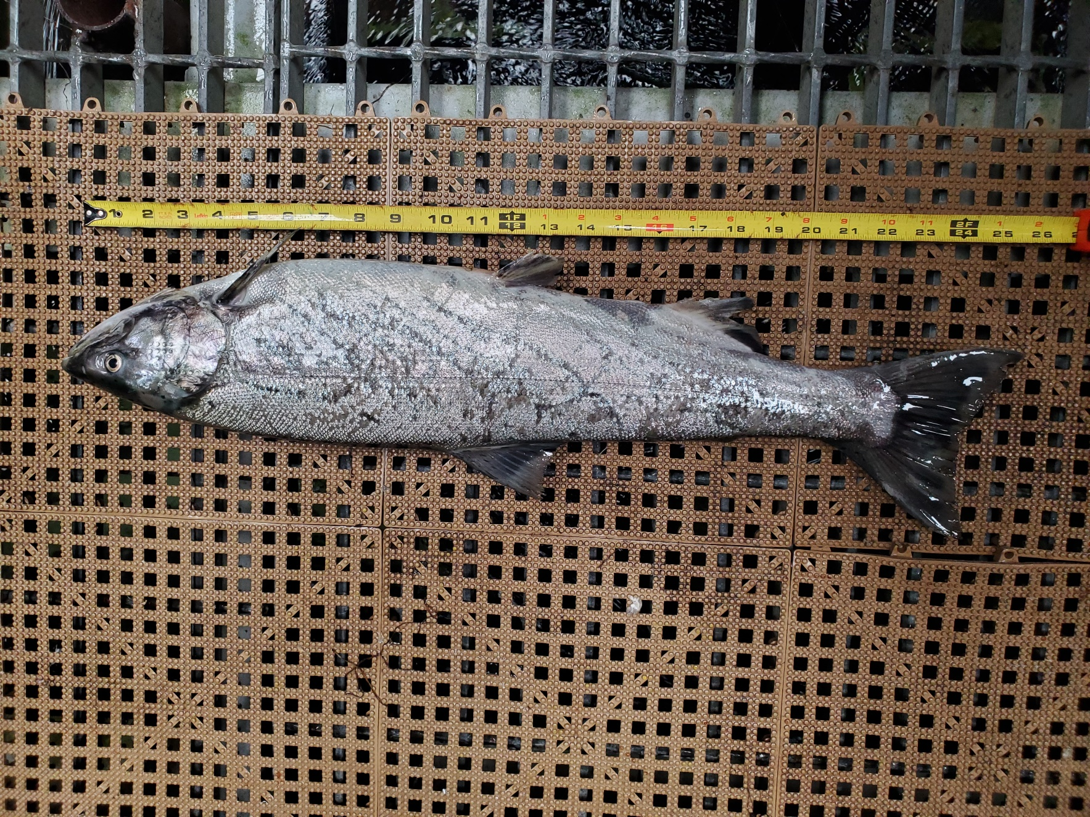

Sincerely,
Bonneville Project Fisheries

